Checklist Mingguan App Guide
For Admin and HR
How to manage accounts, roles and outlets from the phone app.
October 2026
For Admin and HR only
HR has the same screens and powers as Admin. This guide covers the admin screens only. Scoring, verifying marks, and Tugasan are explained in the Area Manager guide.
Pictures in this guide were taken from the real app using sample data. Names and payroll numbers are deliberately blurred.

Contents
- Part 1 — App basics
- Part 2 — Managing people
- Part 3 — Managing outlets
- Part 4 — Roles and your own account
- Part 5 — Common questions

Part 1 — App basics

What Admin and HR do
Admin and HR manage people and outlets: adding and editing accounts, changing roles and postings, and opening or closing outlets. They do not score staff, verify marks, handle returns, log asset issues, or use the reports.
Admin and HR can | Admin and HR cannot
Add an account for any role. | Score staff or SV/AS, or verify marks
Promote, demote or transfer people between Shop Staff, Store Staff, Store Clerk, Supervisor, Area Manager and Manager, and between Admin and HR | Reset another person's password (Users can change password in app). Forgotten passwords need to be reset in the databases.
Change a person's outlet, or the outlets an Area Manager covers | Delete an account (deactivate it instead). MIS can delete a user's account from the databases.
Change a payroll number when HR issues a new one | Delete marks or asset issues (do it in the databases)
Deactivate and reactivate accounts
Add, rename, close and reopen outlets
View any person's weekly marks

The items on the right are handled by Setiahub-MIS, outside the app.

The three admin tabs
Admin and HR have three tabs along the bottom of the screen.
Tab | What it shows | What you do there
Users | Each account shows the name, payroll number, outlet, and role. Deactivated accounts are greyed out. | Find a person and open them to edit, or tap + Add for a new account.
Roles | Each role has its active holders, and a record of promotions and demotions. | Check who holds what. Tap a name to open that person.
Branches | Every outlet, with its staff, Supervisor, and Area Manager, counts. | Open an outlet to rename or close it, or tap + Add for a new outlet.

Signing in
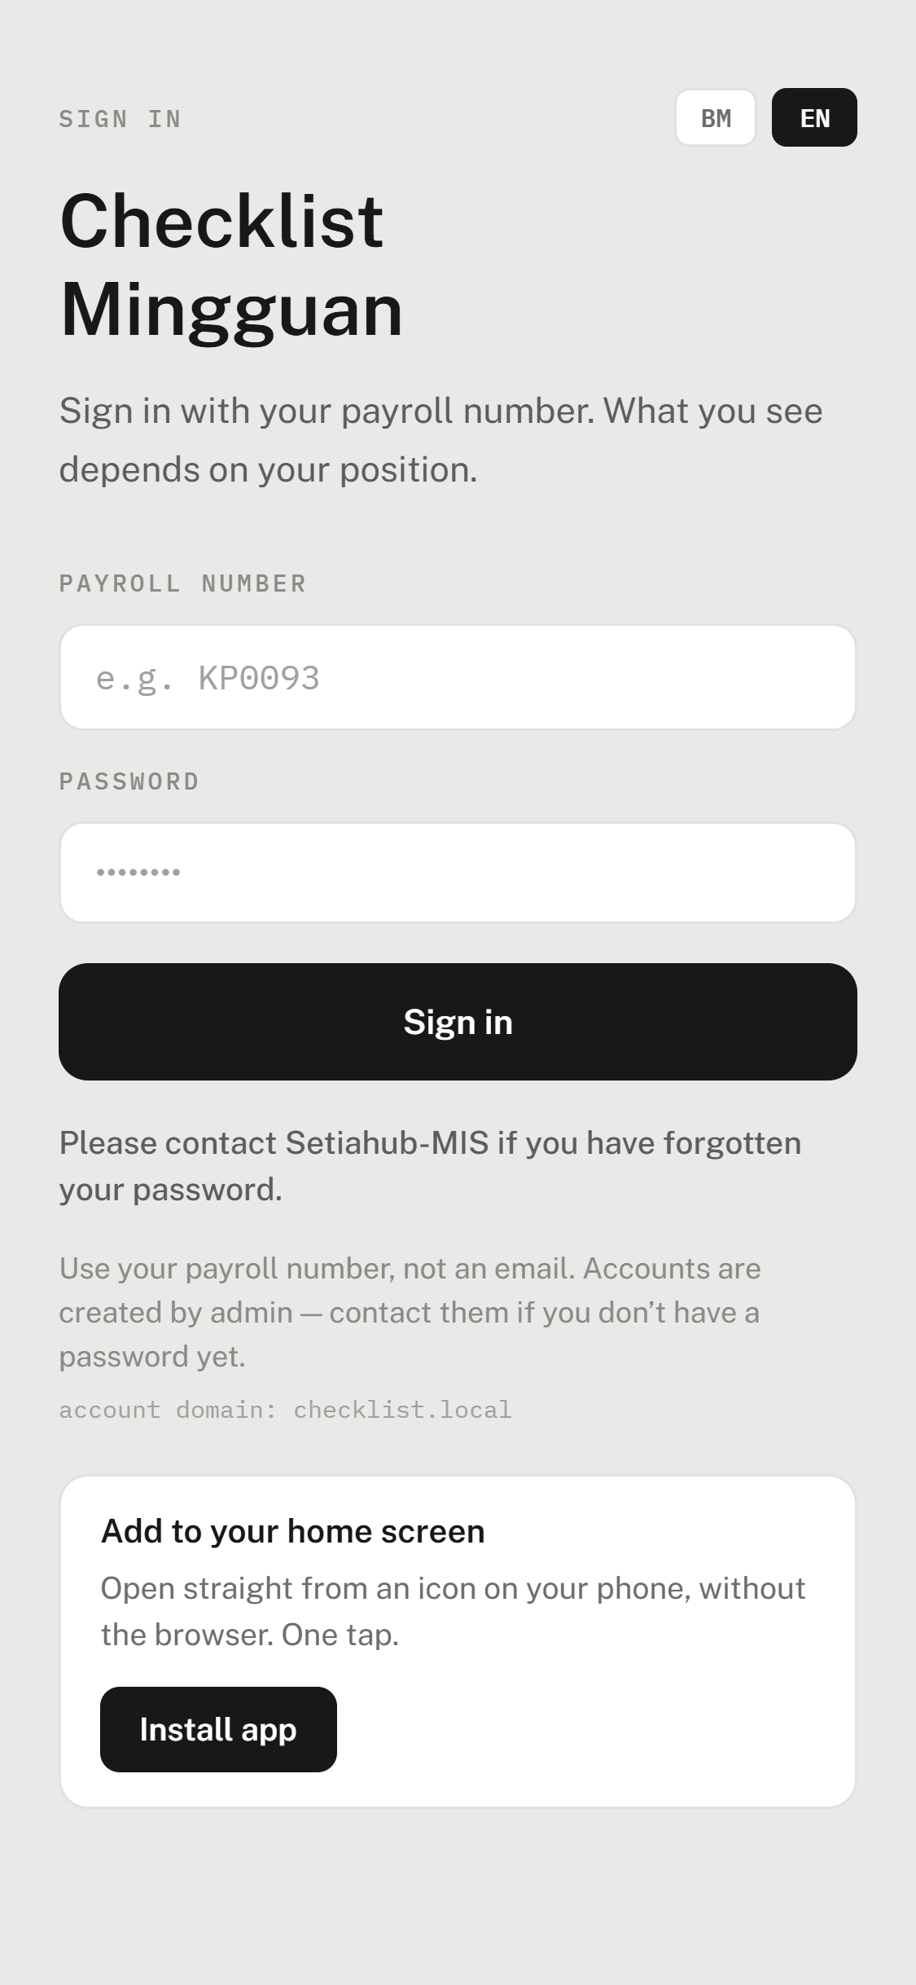  The sign-in screen, in English. | 1. Open the Checklist Mingguan app on your phone.  2. Type your payroll number (for example, AD0001). Not an e-mail.  3. Type your password.  4. Tap Sign in. Admin and HR open straight onto the admin screens.  Tap EN at the top to switch the app to English; BM switches back to Malay. This guide uses the English labels.

For security, the app signs you out by itself after 15 minutes without a touch, or 3 hours after signing in. Sign in again to carry on; anything already saved is safe. All accounts have this setting to protect data such as phone is lost or stolen.

Part 2 — Managing people

The Users list
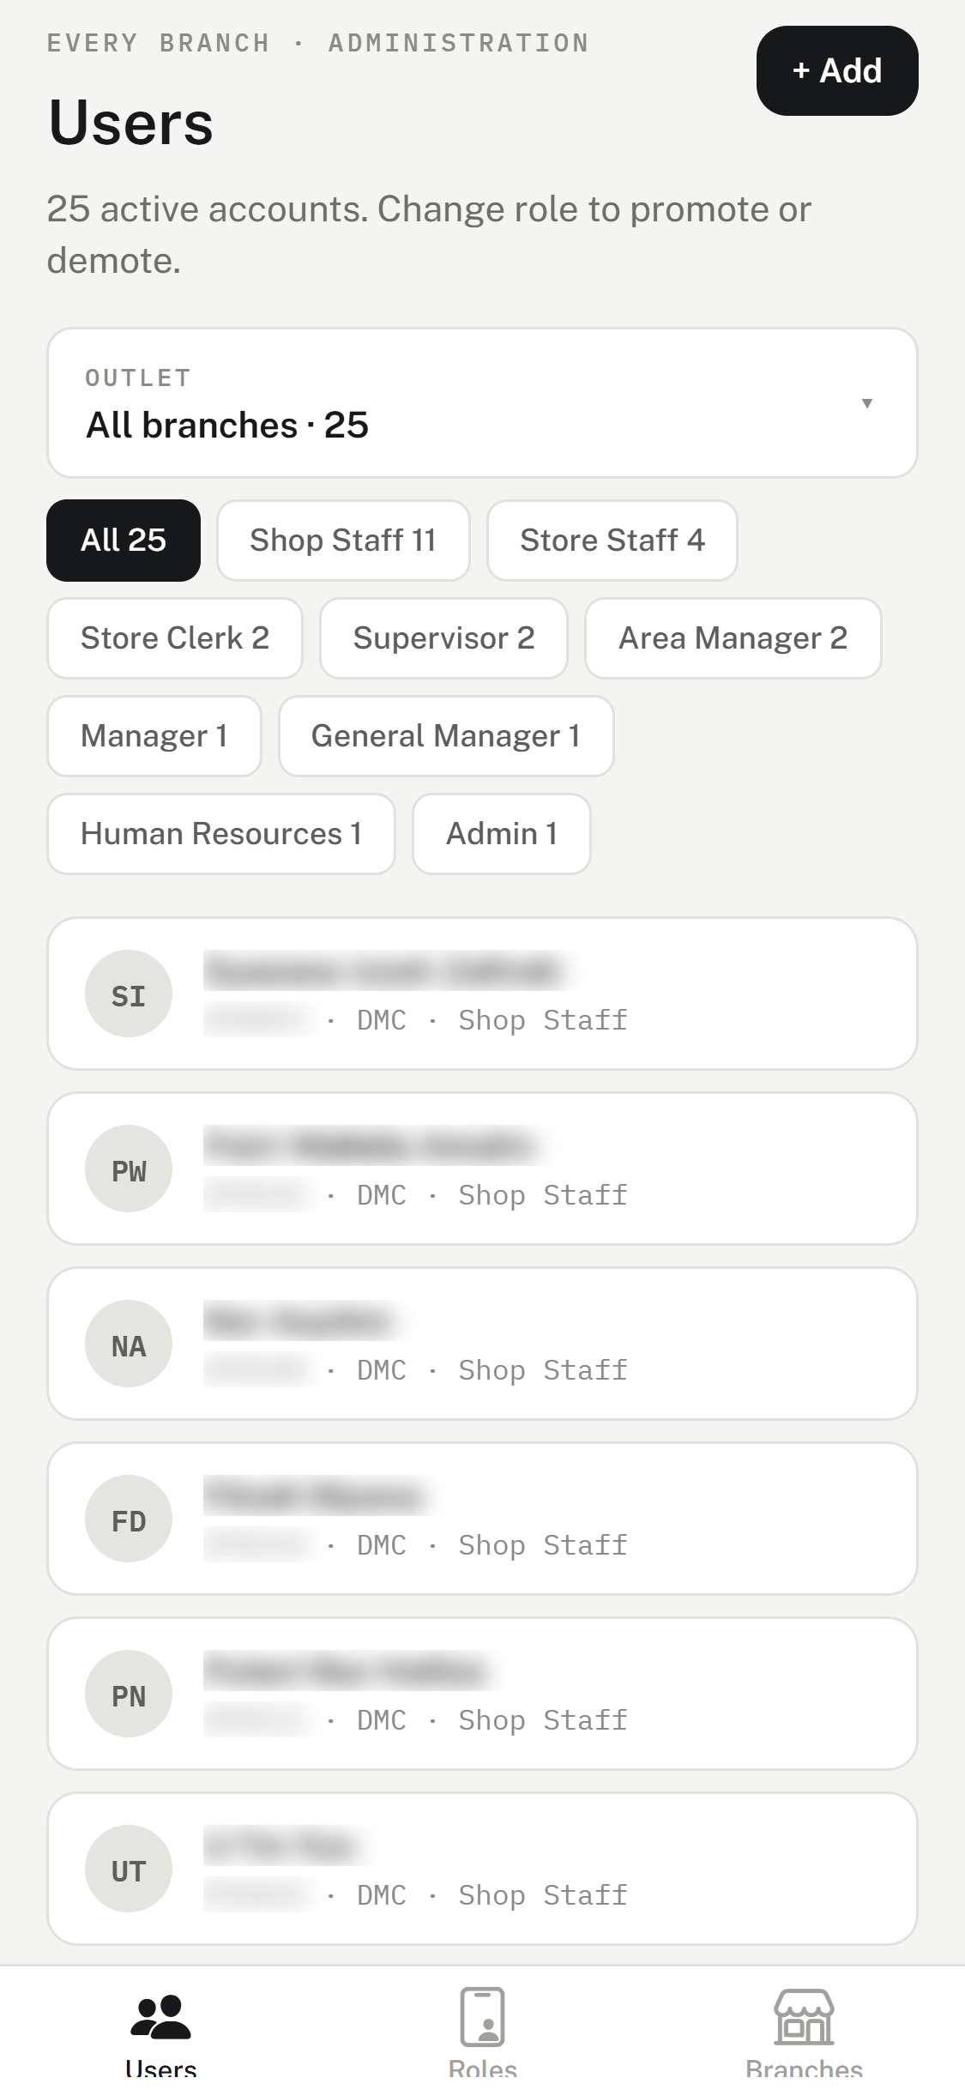  The Users tab. | • The number under the title counts active accounts, and deactivated ones if any.  • The Outlet dropdown shows one outlet at a time; All branches shows everyone.  • The chips filter by role. The number on each chip is how many accounts hold that role.  • Each card shows the name, then payroll number · outlet · role. HQ means head office.  • Tap a card to open that person.

Adding a person
On Users, tap + Add. Fill the form from top to bottom:
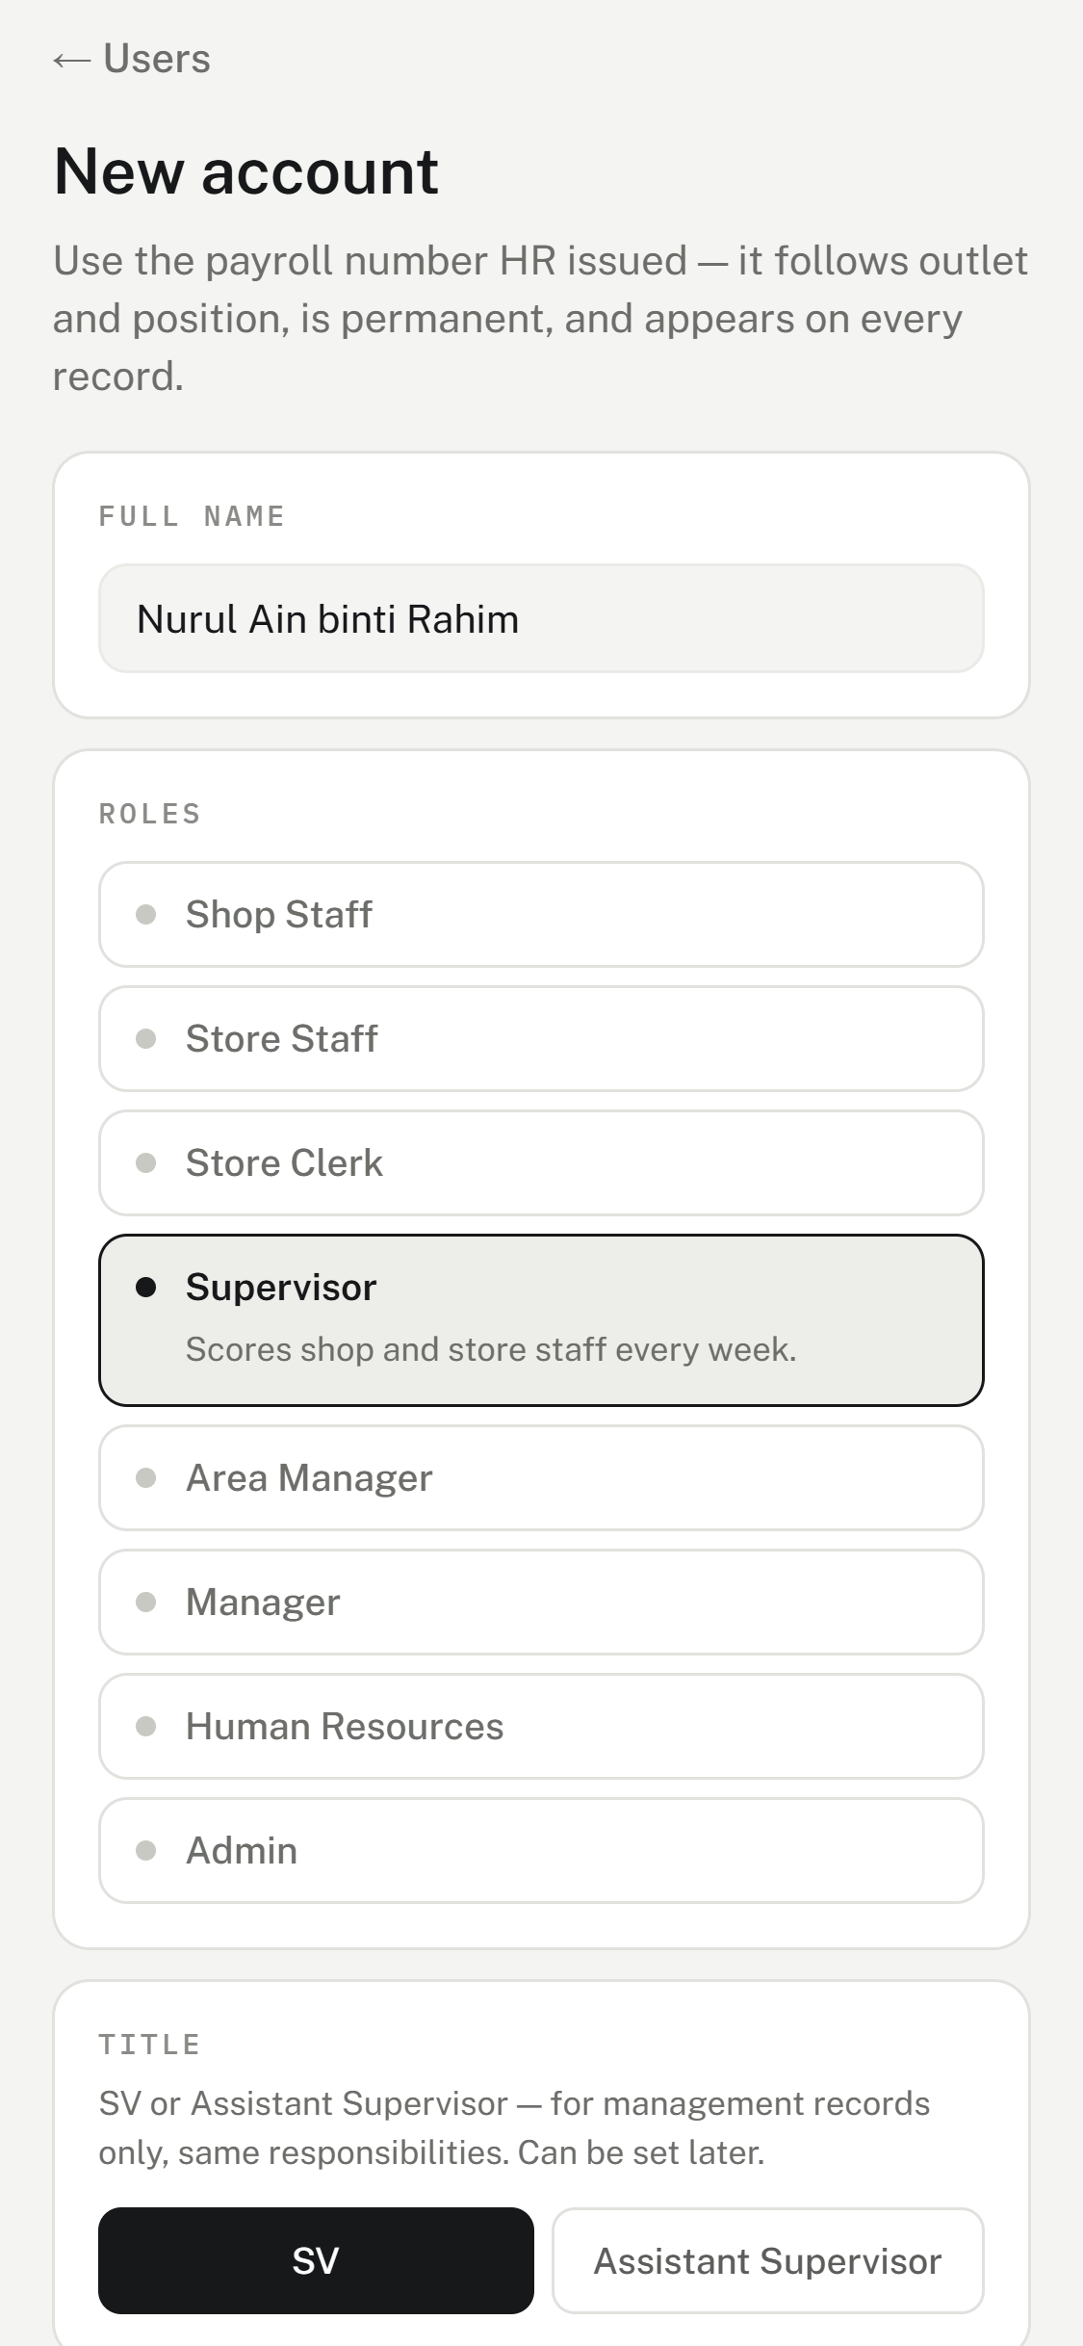  Name, role, and title. | 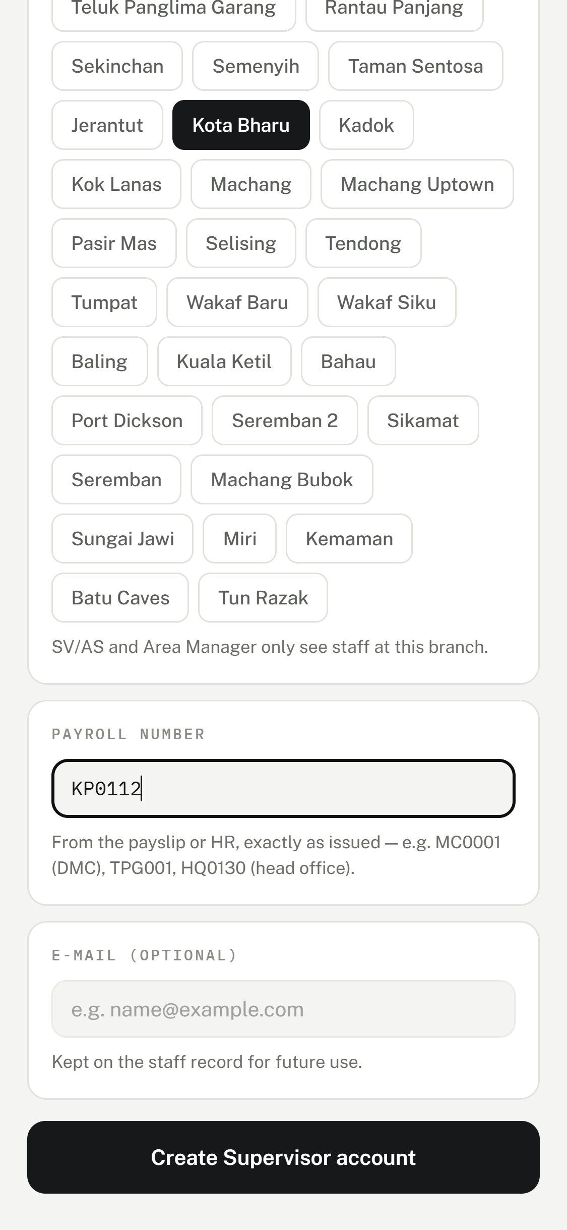  Outlet, payroll number, and e-mail.

- Full name — as on the payslip, for example Nurul Ain binti Rahim.
- Role — tap one. For a Supervisor, also pick the Title: SV or Assistant Supervisor. It is a label for management records only; both do the same work, and it can be set later.
- Branches — tap the outlet they work at. Store Staff and Store Clerks can only be posted to HQ. An Area Manager can cover several outlets: the first one tapped is their home outlet. Managers, HR, and Admin have no outlet; they see every outlet.
- Payroll number — exactly as HR issued it, for example MC0001, TPG001 or HQ0130. The app never makes one up, and a number can only be used once.
- E-mail — optional.
- Tap the black button at the bottom, for example, Create Supervisor account.
The login is ready at once
The person can sign in straight away with their payroll number and the starting password, 123456.
Ask them to change it under My account after their first sign-in.

Supervisors and Area Managers can also add people, but only Shop Staff (and, for an Area Manager, Supervisors) at their own outlets. Every other role is added by Admin or HR.

Editing a person
Open the person from Users or Roles. Their screen is one long page:
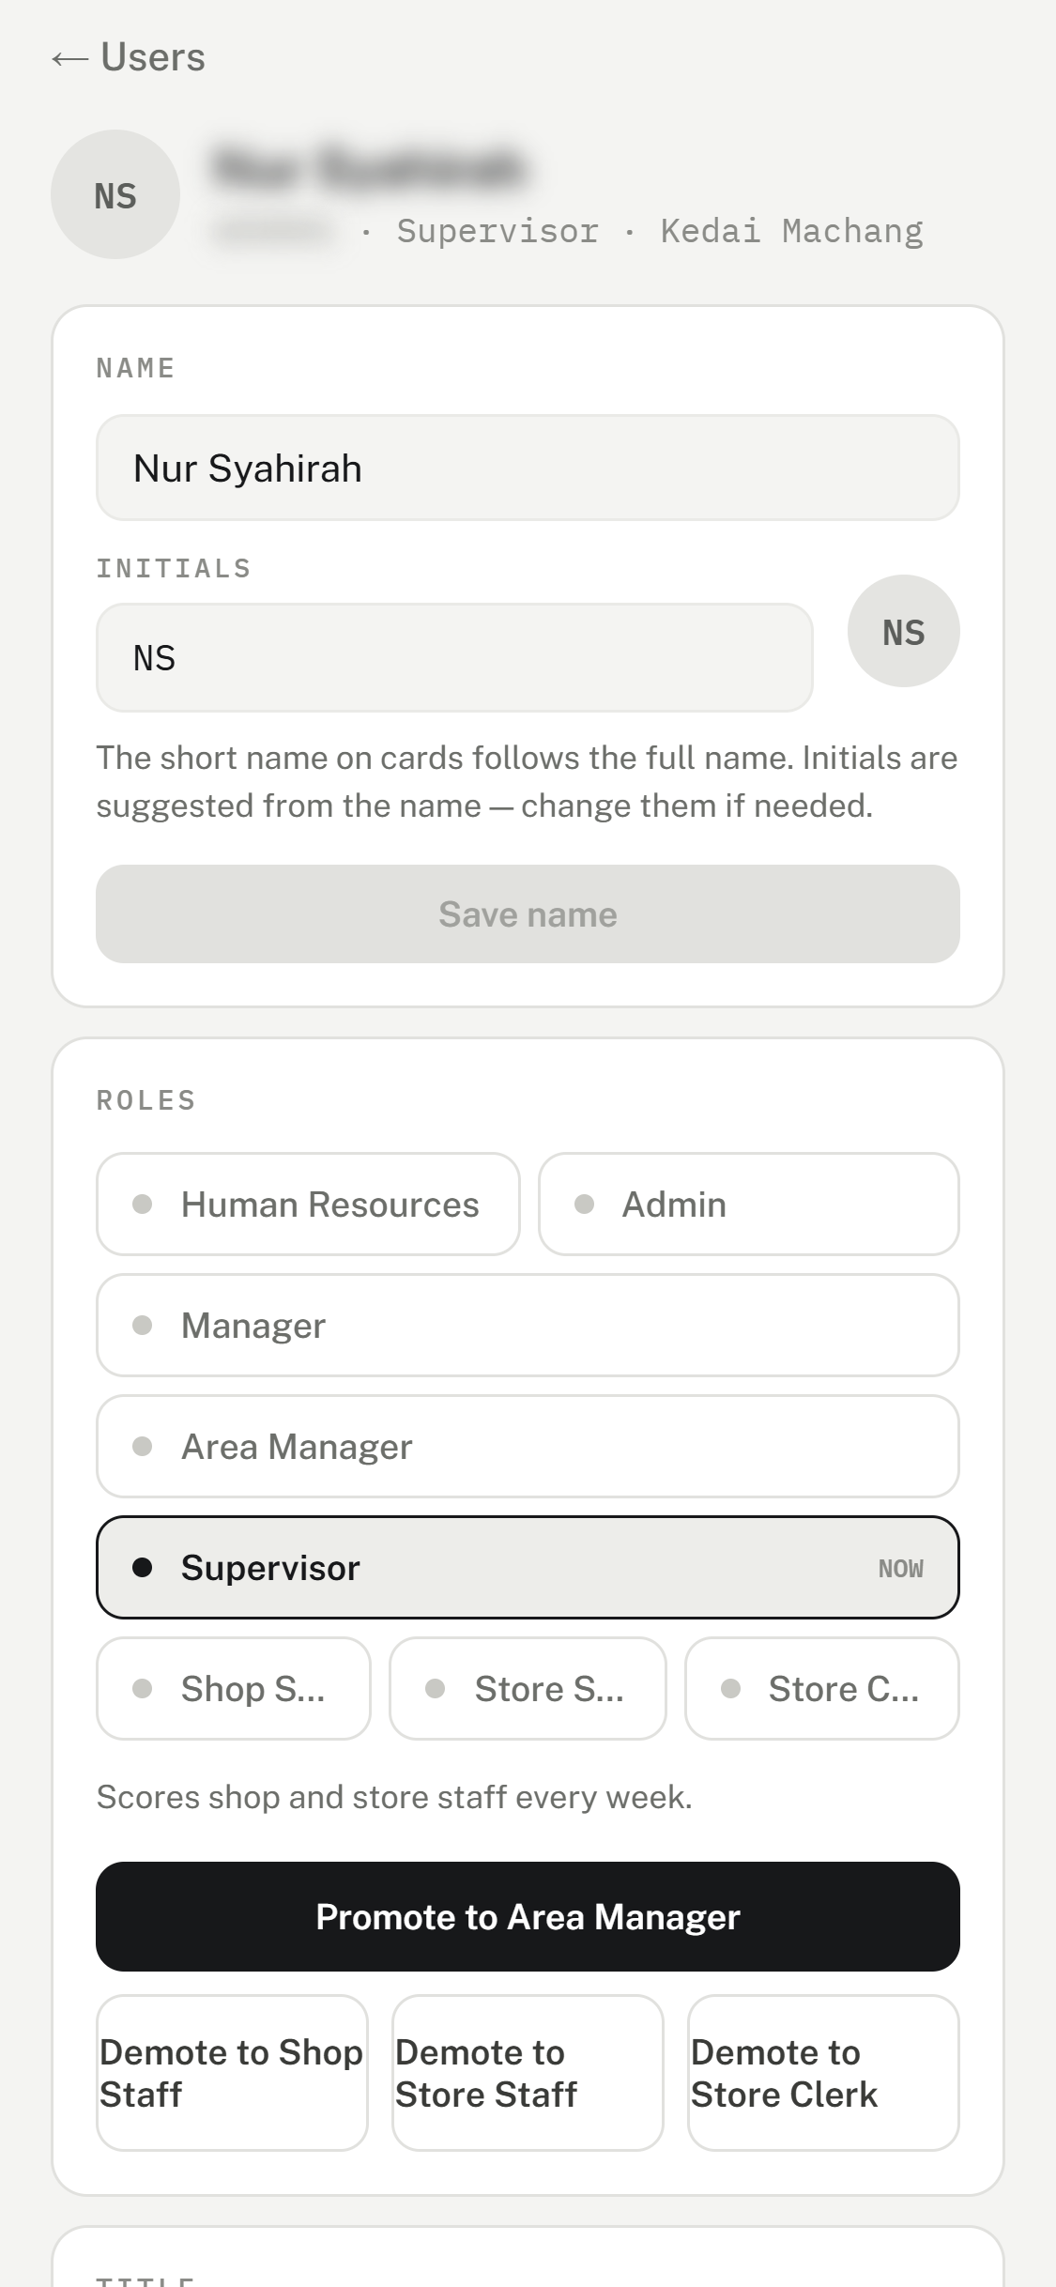  Name and role. | 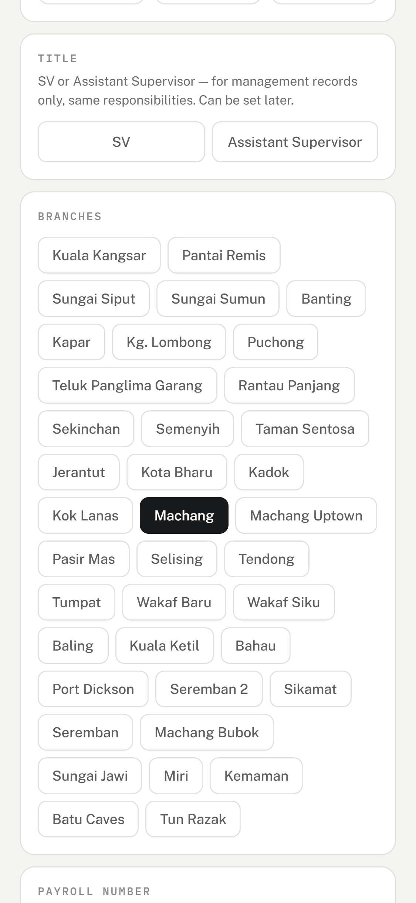  Title and outlet.

- Name — correct the name or the initials, then tap Save name. Initials are suggested from the name; fix them for names with bin or binti. 1 to 3 letters.
- Roles — the current role is marked NOW. Tap Promote to …, Demote to …, or Transfer to …. Roles move one step at a time; Admin and HR transfer into each other. Past marks stay saved.
- Title — Supervisors only: tap SV or Assistant Supervisor.
- Branches — tap the new outlet. For an Area Manager, tap to add or remove an outlet; at least one must stay.
Taps save straight away
Role, title and outlet change the moment you tap — there is no Save button for them. Check before you tap.

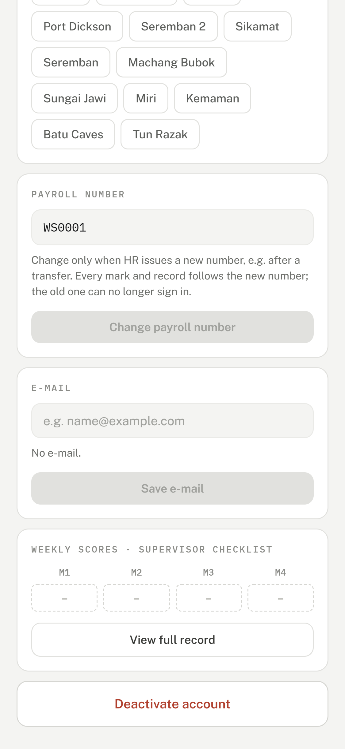  Payroll number, e-mail, weekly scores and deactivate. | • Payroll number — only when HR issues a new number, for example after a transfer. Type it, tap Change payroll number, then confirm. All marks follow the new number, the person signs in with it from now on, and the old one stops working. The password is unchanged.  • E-mail — type it and tap Save e-mail. The employees can add this themselves.  • Weekly scores — this month at a glance. View full record opens their whole history.  • Deactivate account — for someone who has left. They can no longer sign in; their records are kept. Reactivate account undoes it.

When the app says no
Every outlet must keep an Area Manager, and the company must keep an Admin. Moving, demoting, or deactivating the last one is refused with a message ending “lantik pengganti dahulu” (appoint a replacement first).
Add or move the replacement in first, then make the change.

Part 3 — Managing outlets

The Branches list
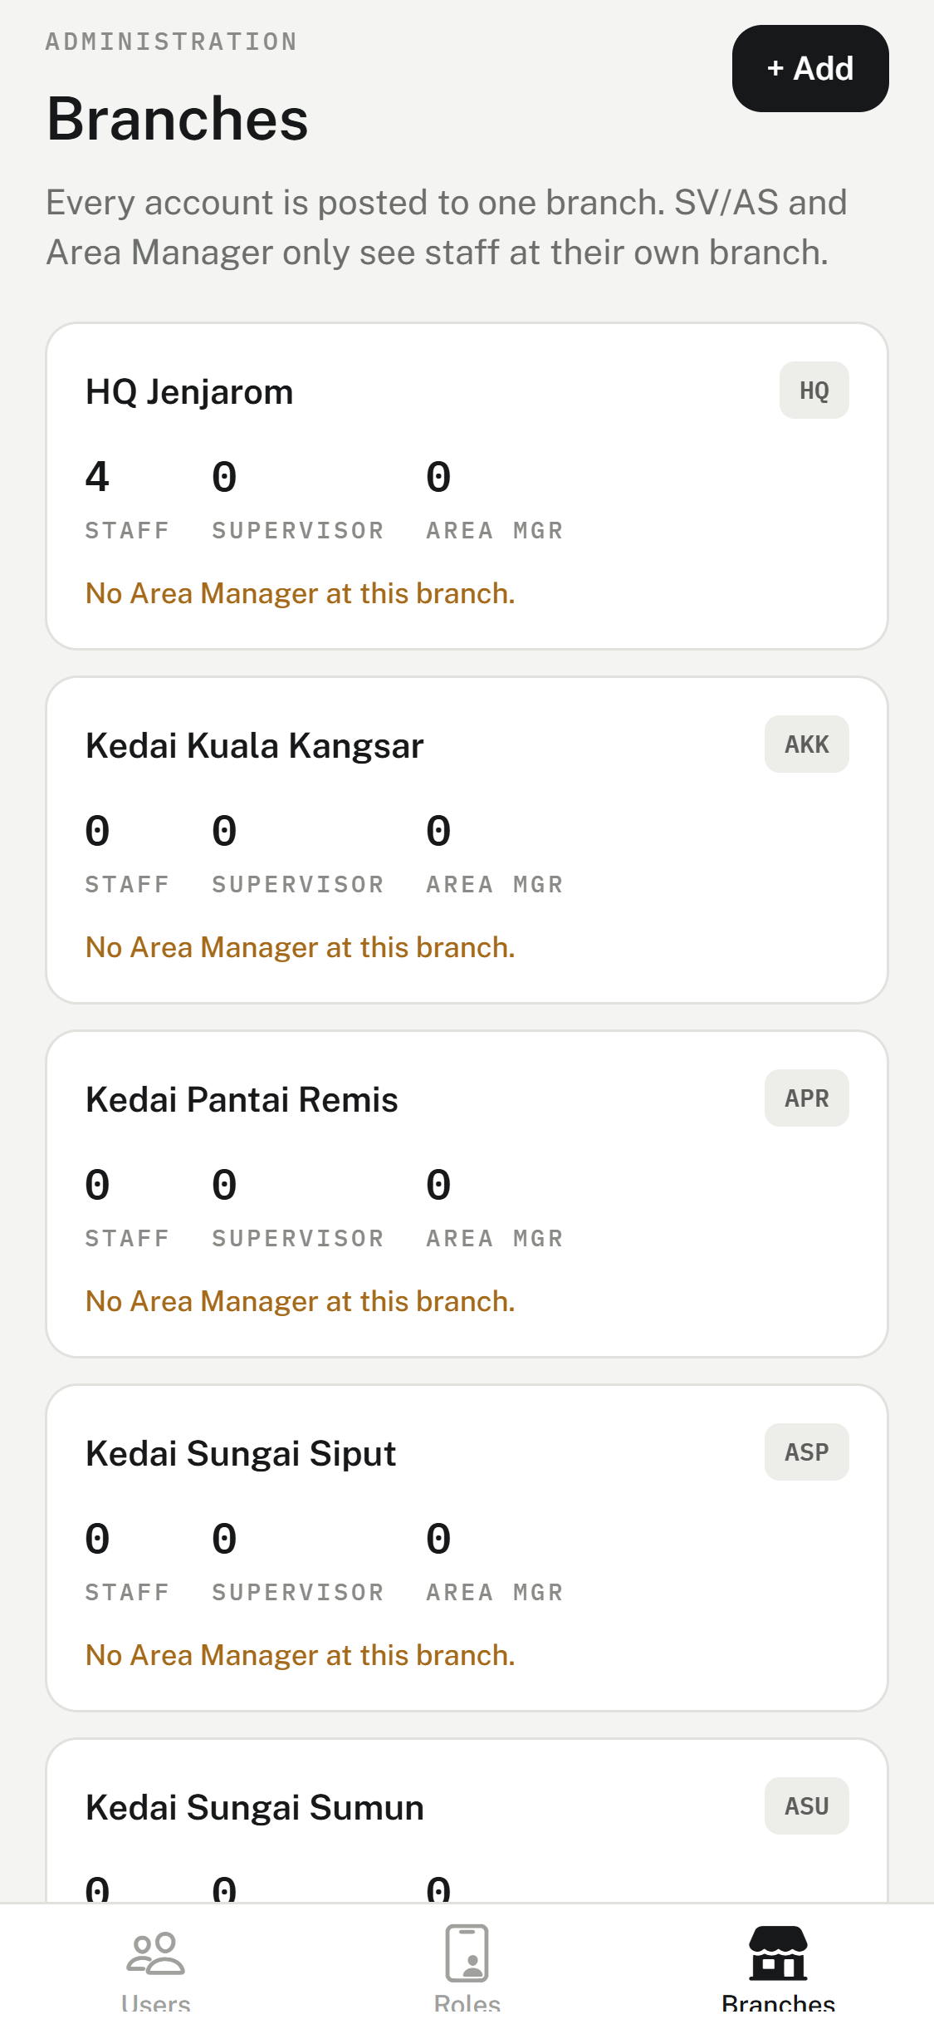  The Branches tab. | • One card per outlet, with its code on the right (for example DMC).  • The three numbers count the outlet's staff, Supervisors and Area Managers.  • No Area Manager at this branch. means nobody is set to sign off its marks yet.  • A closed outlet is greyed out.  • Tap a card to open that outlet.

Adding an outlet
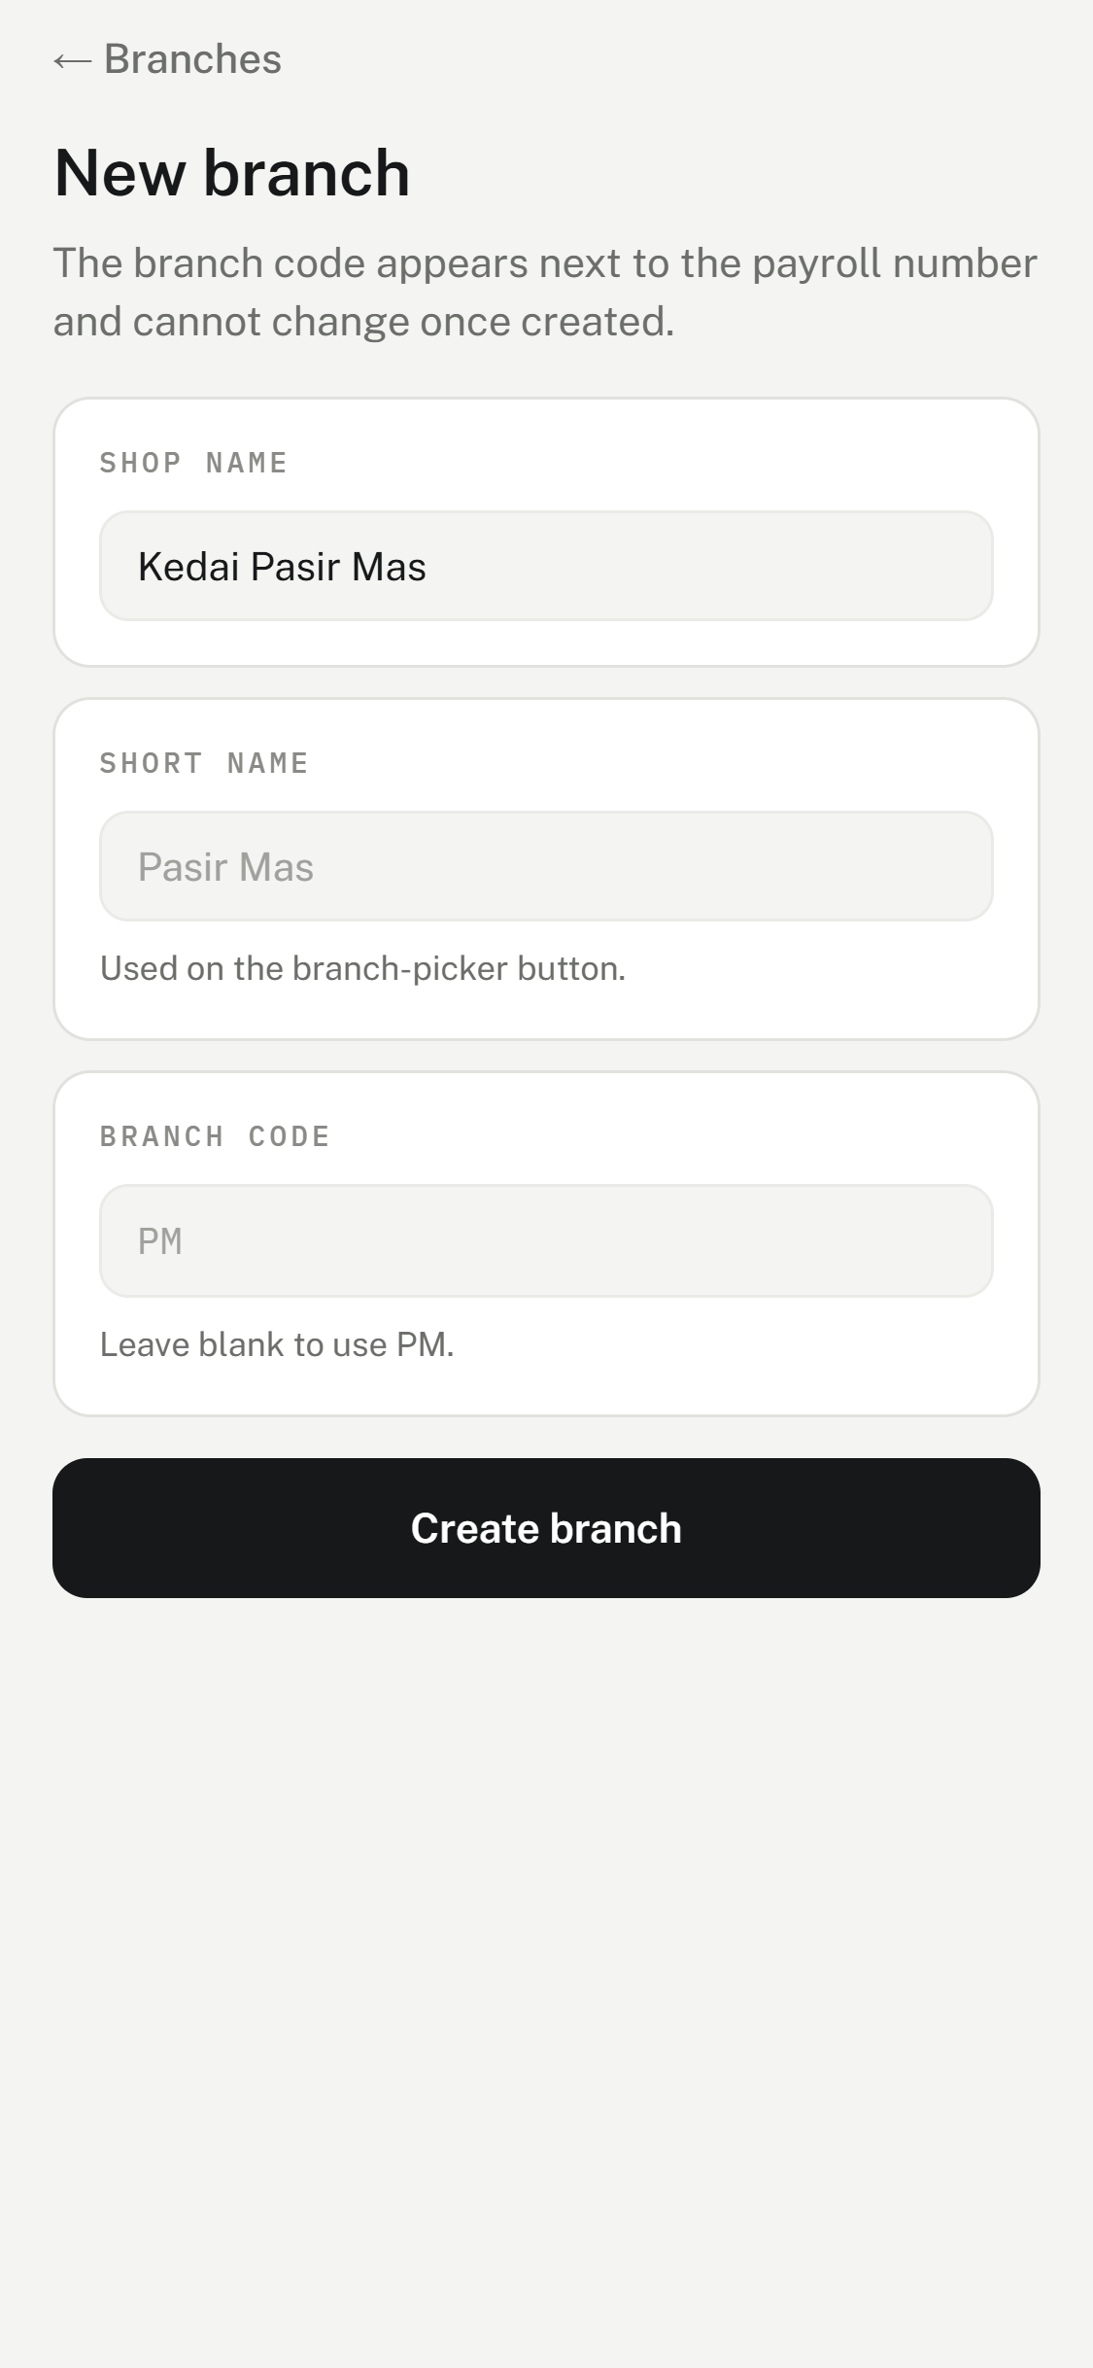  A new outlet. | 1. On Branches, tap + Add.  2. Shop name — the full name, for example, Kedai Pasir Mas.  3. Short name — what the outlet dropdowns show. Leave it blank to use the one suggested.  4. Branch code — 2 to 5 letters or numbers. Leave it blank to use the suggested code.  5. Tap Create branch.

Choose the code carefully
The branch code appears on every record and cannot be changed after the outlet is created.

A new outlet comes with its full Aset kedai list (A) AIR-COND to J) LAIN-LAIN). Next, give it an Area Manager: open the Area Manager under Users and tap the new outlet under Branches.

Renaming or closing an outlet
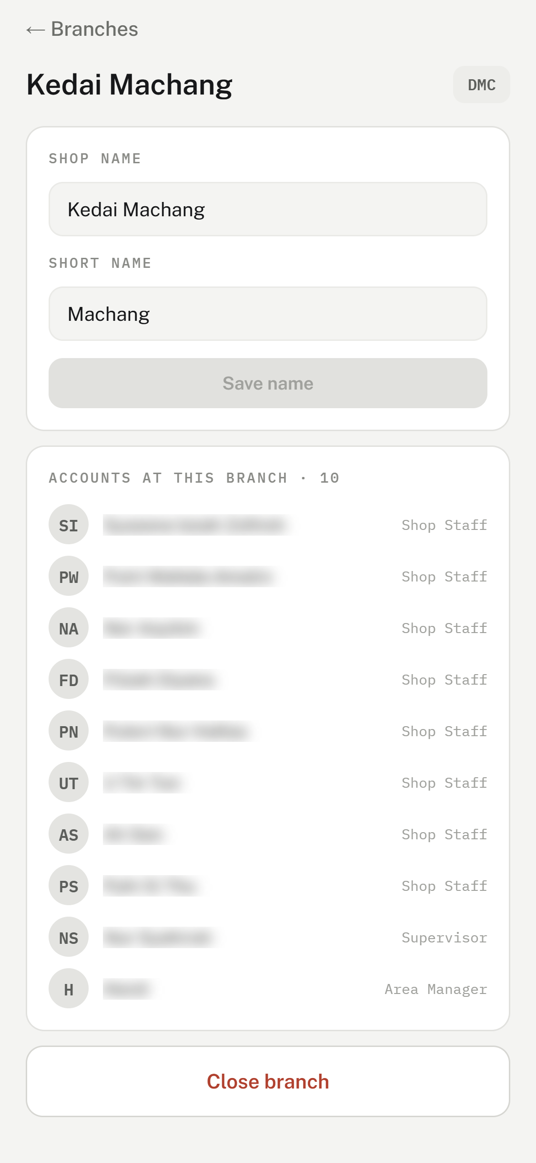  One outlet. | • Change Shop name or Short name, then tap Save name. The code stays the same.  • Accounts at this branch list everyone posted here.  • Close branch — a closed outlet keeps all its past marks and records, but can no longer be picked for a new account. Reopen branch brings it back.  • An outlet with people still posted to it cannot be closed. Move each of them to another outlet, or deactivate them, first.

Part 4 — Roles and your own account

The Roles tab
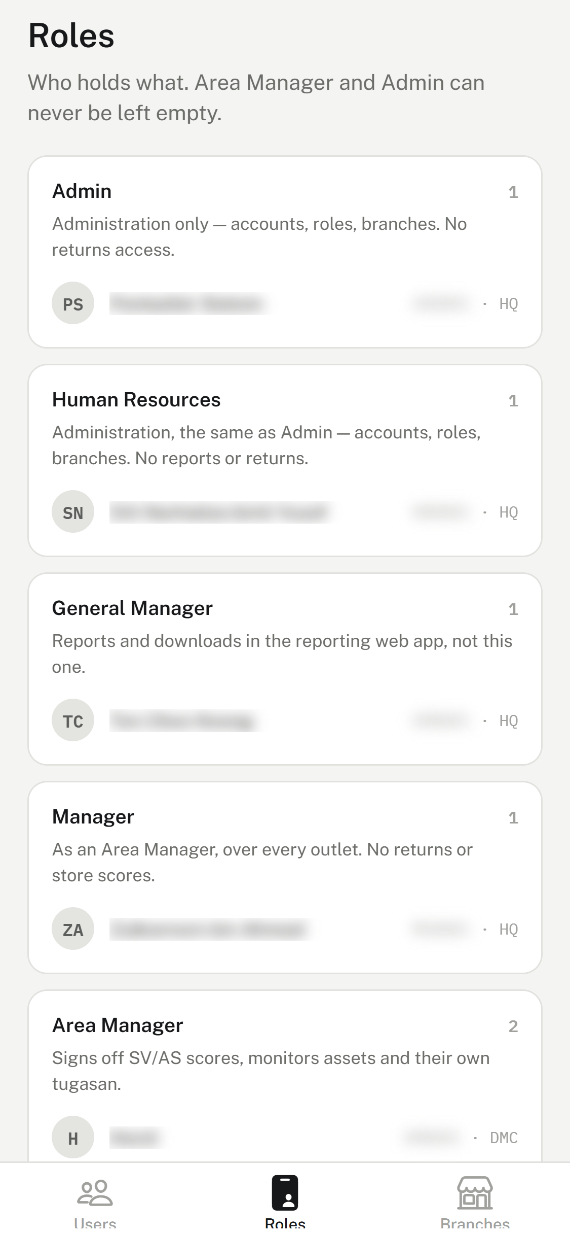  Each role and who holds it. | 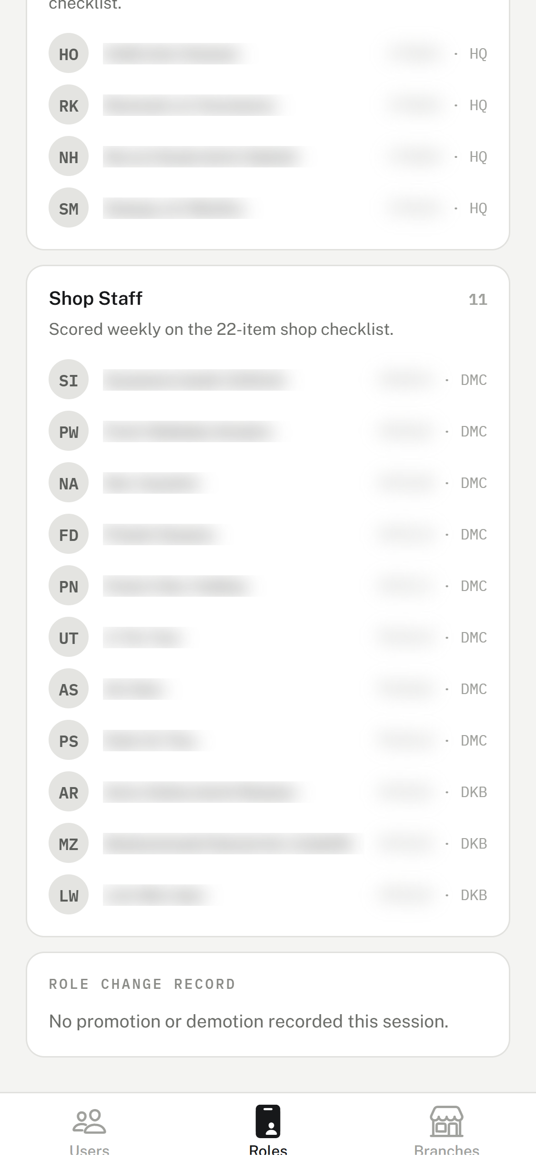  The role change record, at the bottom.

- Roles are listed from Admin down to Shop Staff, each with a short description and its active holders.
- No active holder. In orange means nobody holds that role.
- Tap a name to open that person.
- Role change record — promotions (UP) and demotions (DOWN) made on this phone since you signed in.

Your own account
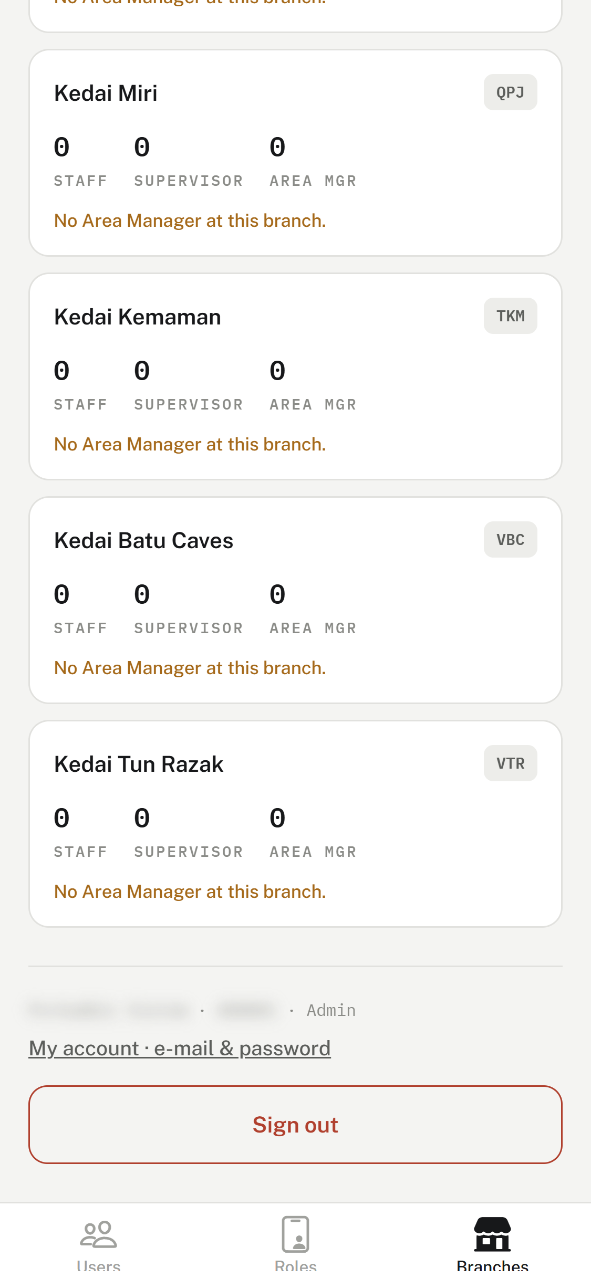  The bottom of the Branches tab. | • Your name, payroll number, and role.  • My account · e-mail & password — save your e-mail, or tap Change password: type the new password twice (at least 6 characters) and tap Save password.  • Sign out — when you are done, especially on a shared phone.

Part 5 — Common questions
Someone moved outlet and got a new payroll number from HR.
Open the person, tap the new outlet under Branches, then change the number under Payroll number. Their marks follow the new number.
Someone has resigned.
Open the person and tap Deactivate account. Accounts are never deleted, and a payroll number is never given to someone else.
An Area Manager is leaving, and the app will not let me deactivate them.
They are the last Area Manager at an outlet. Post the replacement to that outlet first, then deactivate.
A new outlet shows “No Area Manager at this branch”.
Open the Area Manager under Users and tap the outlet under Branches to add it to their coverage.
“The server refused this change. Only admin may edit accounts.”
You are not signed in as Admin or HR, or your sign-in has expired. Sign out and sign in again with your own account.
Someone has forgotten their password.
Passwords are not reset in the app. Contact Setiahub-MIS, who will give them a new one. They can change it under My account after signing in.
The wrong role was tapped by mistake.
Tap the move back straight away (for example Demote to … after a wrong Promote to …). Both changes appear in the Role change record.

